_{Zoom Mac SDK}

Modification History

Revision | Date | Originator | Comments
1 | 8/10/2016 | Zoom engineering | First version
2 | 1/23/2017 | Zoom engineering | 1. Support to join Webinar meeting with as Panelist;  2. Support to pin/spotlight video;  3. Support H.323/SIP callout directly  4. Add watermark “Powered by Zoom”  5. Support to start/join meeting without audio;  6. Support to start/join meeting without video;  7. Support Multi-share;

Note that the mac SDK from Zoom is distributed under a separate SDK agreement. Please make sure that you read the terms and conditions of the SDK agreement before using the SDK. Please visit Zoom developer portal if you have questions.

Introduction and Pre-Requisite
In order to use the SDK, you need to make sure that the RETS API and the mobile SDK is enabled in your account. If not, please contact your account rep or contact Zoom support. Our mac SDK is written in object C.

- Get the SDK key and secret from your zoom account. This key/sec is same as the
one used for mobile SDK

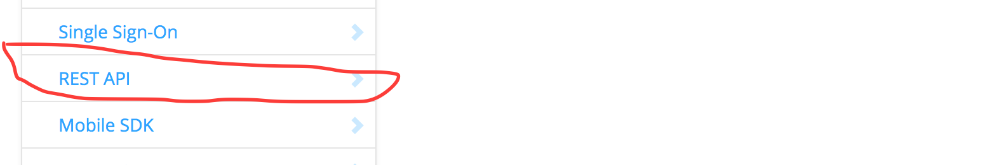

- Get the REST API Key/Sec from your zoom account

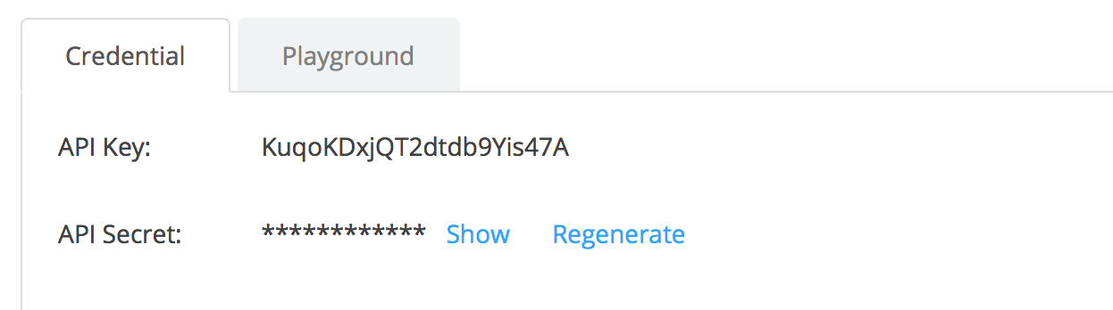

- Call REST API “getbyemail” and this should return the user id and user token

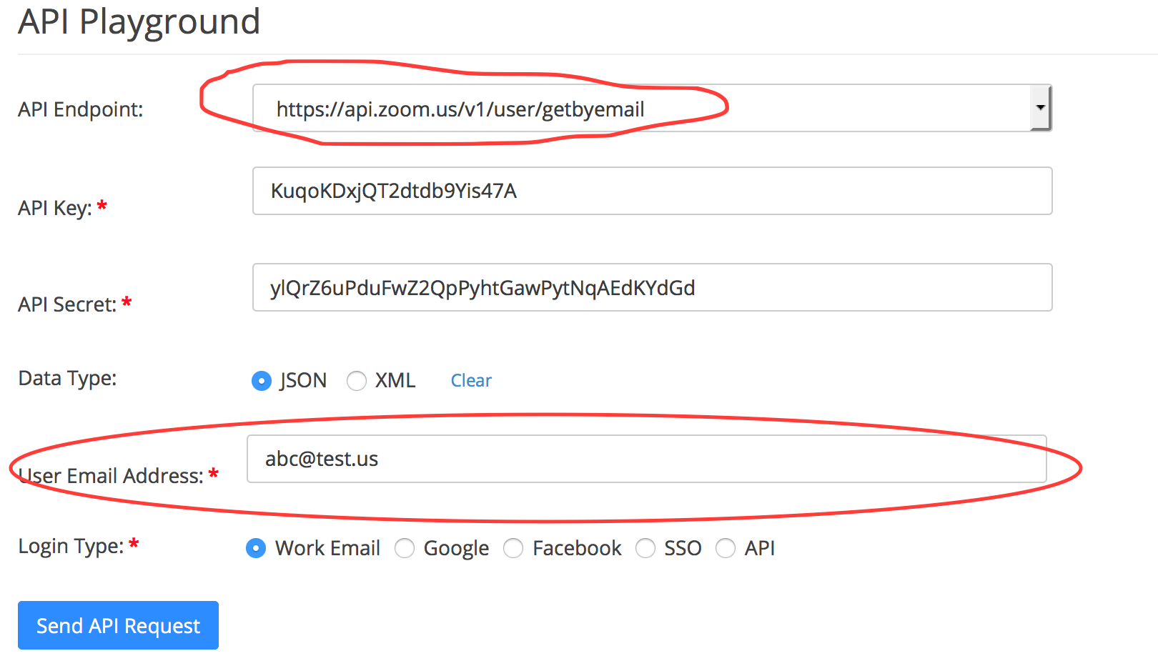

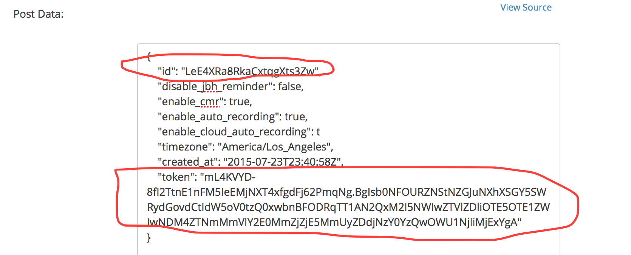

SDK Functions

SDK Initialization
Please follow the ZoomSDKSample.xcproject project that is part of our SDK bundle (AppDelegate.mm) and look at the initialization functions to find how to use ZoomSDK.
Interfaces:
- sharedSDK
@return an ZoomSDK instance, e have done initialisation ourself.
- setZoomDomain:(NSString*)domain
@param domain:set a web domain url you want to use.
- getAuthService
@return ZoomSDKAuthService instance, use this to call Auth fuction.
- getMeetingService
@return ZoomSDKMeetingService instance, use this to get meeting detail info and modify meeting UI.
- getSettingService
@return ZoomSDKSettingService instance, use this to configure the meeting setting.
- getPremeetingService
@return ZoomSDKPremeetingService instance, use this to schedule\list meeting.

Auth Service

Zoom SDK supports two options for user authentication.

- You can pass the user id of the user to the SDK initialization and all the meetings will start on that user’s account. This is referred to as API user
- There are times it might be cumbersome to get the user id and you might want to distribute your app to all Zoom users – in this case, you can ask the user to enter the Zoom login credentials (username /password) in your app and then pass it to the SDK. This is referred to as normal user

Use ZoomSDKAuthService interface for the user authentication.

- (ZoomSDKError)sdkAuth:(NSString*)key appSecret:(NSString*)secret
@param key: your client key, also known as API key.
@param secret: your client secret
@return a error enum to tell the call result directly, and also can get a callback from its delegate.
- (BOOL)isAuthorized
@return a BOOL value to tell you the ZoomSDK is authed or not.

- (ZoomSDKError)login:(NSString*)userName Password:(NSString*)password RememberMe:(BOOL)rememberMe;
@param userName: your login user name
@param password: password related to your username
@param rememberMe: if you want to login automatically next time, set YES, or NO to not remember your password.
@return a error enum to tell the call result directly, and also can get a callback onZoomSDKLogin from its delegate.

- - (ZoomSDKError)logout;
@return a error enum to tell the call result directly, and also can get a callback onZoomSDKLogout from its delegate.

- - (ZoomSDKAccountInfo*)getAccountInfo
@return ZoomSDKAccountInfo object if call successfully.
ZoomSDKAccountInfo interface:
- (NSString*) getDisplayName
return the display name of the login account.

Callback from delegate:

- (void)onZoomSDKAuthReturn:(ZoomSDKAuthError)returnValue
@return a error enum to tell the auth process succefully or not.
- (void)onZoomSDKLogin:(ZoomSDKLoginStauts)loginStatus;
@return a ZoomSDKLoginStauts enum to tell if client login successfully.
ZoomSDKLoginStauts enum:
ZoomSDKLoginStauts_Idle, // Not login yet
ZoomSDKLoginStauts_Processing, // Login in progress
ZoomSDKLoginStauts_Success, // Login Success
ZoomSDKLoginStauts_Failed // Login Failed
- (void)onZoomSDKLogout

Pre-Meeting Service
:
- (ZoomSDKError)scheduleMeeting:(ZoomSDKScheduleMeetingItem*)meetingItem;
@param meetingItem the specified meeting user want to schedule.
ZoomSDKScheduleMeetingItem interface:
You can set follow property of ZoomSDKScheduleMeetingItem
NSString* meetingTopic;
NSString* meetingPassword;
time_t meetingStartTime;
time_t meetingDuration;
BOOL joinBeforeHost;
BOOL usePMI;
BOOL turnOffVideoForHost;
BOOL turnOffVideoForAttendee;
@return A ZoomSDKError to tell client whether the meeting has been
scheudled successfully or not synchronously, also get callback
onScheduleOrEditMeting from delegate asynchronously.
- (ZoomSDKError)editMeeting:(ZoomSDKScheduleMeetingItem*)meetingItem MeetingUniqueID:(unsigned int)meetingUniqueID;
* @param meetingItem the user create to edit meeting.
* @param meetingUniqueID the specified meeting Unique ID user want to
edit.
@return A ZoomSDKError to tell client whether the meeting has been
scheudled successfully or not synchronously.also get callback
onScheduleOrEditMeting from delegate asynchronously.

- – (ZoomSDKError)deleteMeeting:(unsigned int)meetingUniqueID;
@param meetingUniqueID the specified meeting Unique ID user want to
delete.
@return A ZoomSDKError to tell client whether the meeting has been
deleted successfully or not synchronously, also get callback
onDeleteMeeting from delegate asynchronously.
- - (ZoomSDKError)listMeeting
This method is used to list all meetings.
@return A ZoomSDKError to tell client whether list meeting action
successfully or not synchronously, also get callback onListMeeting
from delegate asynchronously.
- - (ZoomSDKMeetingItem*)getMeetingItem:(unsigned int)meetingUniqueID;
@param meetingUniqueID the specified meeting Unique ID user want to
get.
@return A ZoomSDKMeetingItem object with meeeting info if function
call successfully.
ZoomSDKMeetingItem interface:
(BOOL)isPersonalMeeting;
(BOOL)isWebinarMeeting;
(BOOL)isRecurringMeeting;
(BOOL)isAllowJoinBeforeHost;
(BOOL)isUsePMIAsMeetingID;
(long long) getMeetingUniqueID;
(long long) getMeetingNumber;
(time_t) getMeetingStartTime;
(time_t) getMeetingDuration;
(NSString*) getMeetingTopic;
(NSString*) getMeetingPassword;

Callback from delegate:
- - (void)onListMeeting:(ZoomSDKPremeetingError)error MeetingList:(NSArray*)meetingList
@param error tell client related to this premeeting event whether
list meeting success or not.
@param meetingList A NSArray contains elements of ZoomSDKMeetingItem

- - (void)onScheduleOrEditMeeting:(ZoomSDKPremeetingError)error MeetingUniqueID:(unsigned int)meetingUniqueID
@param error tell client related to this premeeting event whether
schedule or edit meeting successfully or not.
@param meetingUniqueID the unique id of the meeting you schedule or
edit.

- - (void)onDeleteMeeting:(ZoomSDKPremeetingError)error
@param error tell client related to this premeeting event whether delete meeting successfully or not.

Meeting Service
After auth is successful, you can use ZoomSDKMeetingService to modify meeting and get meeting detail info.

Start, Join, Leave meeting interfaces
- - (ZoomSDKError)startMeeting:(ZoomSDKUserType)userType userID:(NSString*)userId userToken:(NSString*)userToken displayName:(NSString*)username meetingNumber:(NSString*)meetingNumber isDirectShare:(BOOL)directShare sharedApp:(CGDirectDisplayID)displayID
isVideoOff:(BOOL)noVideo isAuidoOff:(BOOL)noAuido;
@param userType: The userType depends on what the client account is, sdk user should use ZoomSDKUserType_APIUser or zoom user: ZoomSDKUserType_ZoomUser
for api user userId\userToken\userNam\meetingNumber is requested, but not need for ZoomSDKUserType_ZoomUser
@param userId: The userId received as a result client user account from Zoom site.
@param userToken: The userToken received as a result client user account from Zoom site.

@param username: The username will be used as display name in the Zoom meeting.
@param meetingNumber The meetingNumber may be generated from a scheduled meeting or a Personal Meeting ID, api user can’t start instant meeting, if zoom user want to start a instant meeting, set meetingNumber to nil.
@param directShare: set YES client will start desktop share directly when meeting started.
@param displayID: set app display ID， client will start share this app directly when meeting started.
@return A ZoomSDKError to tell client whether the meeting started or not
callback: - (void)onMeetingReturn:(ZoomSDKMeetingError)error internalError:(NSInteger)internalError
- - (ZoomSDKError)joinMeeting:(ZoomSDKUserType)userType toke4enfrocelogin:(NSString*)toke4enfrocelogin webinarToken:(NSString*)webinarToken participantId:(NSString*)participantId meetingNumber:(NSString*)meetingNumber displayName:(NSString*)username password:(NSString*)pwd isDirectShare:(BOOL)directShare sharedApp:(CGDirectDisplayID)displayID
isVideoOff:(BOOL)noVideo isAuidoOff:(BOOL)noAuido;
@param userType: The userType depends on what the client account is, sdk user should use ZoomSDKUserType_APIUser or zoom user: ZoomSDKUserType_ZoomUser
for api user you can input parameter: toke4enfrocelogin\ participantId, but not permit for ZoomSDKUserType_ZoomUser
@param toke4enfrocelogin：when join a meeting need login, this param is needed.
@param webinarToken: when join a webinar meetin, if u want to be panelist after join successs, this is needed.
@param participateId
@param username The username will be used as display name in the Zoom meeting.

@param meetingNumber The meetingNumber used to join the meeting.
@param pwd, The meeting password which used to join the meeting, if there does not exist meeting password, just set pwd to nil or @"".
@param directShare: set YES client will start desktop share directly when meeting joined.
@param displayID: set app display ID， client will start share this app directly when meeting joined.
@param isVideoOff if u want to start a meeting with no video set
YES.
@param isAudioOff if u want to start a meeting with no audio set
YES.
@return A ZoomSDKError to tell client whether can join the meeting or not
callback: - (void)onMeetingReturn:(ZoomSDKMeetingError)error internalError:(NSInteger)internalError
- - (void)leaveMeetingWithCmd:(LeaveMeetingCmd)cmd
@param cmd, leave meeting by the command type, only host can user command LeaveMeetingCmd_End to end meeting, or you can use LeaveMeetingCmd_Leave to leave meeting.

Modify Meeting interface

Show, hide, move and minimize UI window in Meeting Interface
Use - (ZoomSDKMeetingUIController*)getMeetingUIController in ZoomSDKMeetingService to get ZoomSDKMeetingUIController instance.

- - (ZoomSDKError)showMeetingComponent:(MeetingComponent)component window:(NSWindow**)window show:(BOOL)show InPanel:(BOOL)inPanel frame:(NSRect)componentFrame;
@param component: a enum specify the meeting component window you
want to modify.
MeetingComponent_MainWindow : main meeting window
MeetingComponent_Audio: audio window
MeetingComponent_Chat: chat window
MeetingComponent_Participants: participate list window
MeetingComponent_MainToolBar: toolbar at the bottom of main
video window
MeetingComponent_ShareToolBar: toolbar at the top of sharing
window
MeetingComponent_Setting：setting window
@param window: you can set a NSWindow object, and it will be
assigned value after the function call successfully, it only works
when @param component select as follow enum:
MeetingComponent_MainWindow
MeetingComponent_Setting
The other component please set nil.
@param show: set YES if you want to show this component window or
No to hide.
@param inPanel: Just forParticipants and chat window, set YES
the selected window will show in the left side of main window, set
No window will show independently.
@param rect: the frame of the component you want to show on screen.
Can be moved and resized Component: MainWindow
Just can be moved Component: the other components.
@param isVideoOff if u want to join a meeting with no video set
YES.
@param isAudioOff if u want to join a meeting with no audio set
YES.
@return A ZoomSDKError enum to tell client whether the meeting UI modify successfully or not synchronously.

- (ZoomSDKError)enterFullScreen:(BOOL)fullScreen firstMonitor:(BOOL)firstView DualMonitor:(BOOL)secondView
@param fullscreen: set YES to enter full screen or No to exit.
@firstView: Set YES if u want modify first screen or NO not to modify.
@secondView: Set YES if u want modify second screen or NO not to modify.
@return A ZoomSDKError enum to tell client whether enter or exit full screen successfully or not synchronously.
- - (ZoomSDKError)switchToVideoWallView
@return A ZoomSDKError enum to tell client whether main video view switch to video wall view successfully or not synchronously.
- - (ZoomSDKError)switchToActiveSpeakerView;
@return A ZoomSDKError enum to tell client whether main video view switch to active speaker view successfully or not synchronously.

- - (ZoomSDKError)minimizeShareFloatVideoWindow:(BOOL)bMin
@param bMin: set YES to minimize the float video window when share, or NO to maximize.
@return A ZoomSDKError enum to tell client whether minimize or maximize share float video window successfully or not synchronously.

- - (ZoomSDKError)moveFloatVideoWindow:(NSPoint)position
@param position: the position you want the float video window move to when sharing.
@return A ZoomSDKError enum to tell client whether move share float video window successfully or not synchronously.

- - (ZoomSDKError)switchFloatVideoToActiveSpeakerMode
@return A ZoomSDKError enum to tell client whether shaer float video view switch to active speaker view successfully or not synchronously.
- - (ZoomSDKError)switchFloatVideoToGalleryMode
@return A ZoomSDKError enum to tell client whether shaer float video view switch to gallery view successfully or not synchronously.

Meeting configuration
Use - (ZoomSDKMeetingConfiguration*)getMeetingConfiguration in ZoomSDKMeetingService to get ZoomSDKMeetingConfiguration instance.
You can use this to set some meeting configuration before meeting start.

- (void)reset
reset the meeting configuration.
Property: you can set follow property before you start meeting
- app display ID for share
CGDirectDisplayID _displayAppID;
- monitor ID for share
CGDirectDisplayID _monitorID;
- FloatVideo position
NSPoint _floatVideoPoint;
- Sharing ToolBar Visible
BOOL _shareToolBarVisible;
- Main video position
NSPoint _mainVideoPoint;
- waiting for host window visible
BOOL _jbhWindowVisible;
- mute on entry
BOOL _enableMuteOnEntry;
- play chime or not
BOOL _enableChime;
- direct share when start meeting or not
BOOL _isDirectShareDestop;

Whiteboard Annotation
Use - (ZoomSDKAnnotationController*)getAnnotationController in ZoomSDKMeetingService to get ZoomSDKAnnotationController instance.
You can use this to control annotation in share whiteboard.

- - (ZoomSDKError)setTool:(AnnotationToolType)type onScreen:(ScreenType)screen
@ param type: select a tool to use.
AnnotationToolType_None,
AnnotationToolType_Pen,
AnnotationToolType_HighLighter,
AnnotationToolType_AutoLine,
AnnotationToolType_AutoRectangle,
AnnotationToolType_AutoEllipse,
AnnotationToolType_AutoArrow,
AnnotationToolType_AutoRectangleFill,
AnnotationToolType_AutoEllipseFill,
AnnotationToolType_SpotLight,
AnnotationToolType_Arrow,
AnnotationToolType_ERASER,
@param screen: which screen’s annotation u want to set.
@return A ZoomSDKError enum to tell client whether set annotation tool successfully or not synchronously.
- - (ZoomSDKError)clear:(AnnotationClearType)type onScreen:(ScreenType)screen
@param type: select a clear type to clear annotation.
AnnotationClearType_All: clear all annotation in whiteboard
AnnotationClearType_Self: clear your annotation in whiteboard
AnnotationClearType_Other: clear other’s annotation in
Whiteboard
@param screen: which screen’s annotation u want to set.
@return A ZoomSDKError enum to tell client whether clear annotation successfully or not synchronously.

- - (ZoomSDKError)setColor:(NSColor*)color onScreen:(ScreenType)screen
@param color: set color u want annotation to use
@param screen: which screen’s annotation u want to set.
@return A ZoomSDKError enum to tell client whether set color successfully or not synchronously.
- - (ZoomSDKError)setLineWidth:(long long)lineWidth onScreen:(ScreenType)screen
@param lineWidth: set format line width u want annotation to use
@param screen: which screen’s annotation u want to set.
@return A ZoomSDKError enum to tell client whether set line width successfully or not synchronously
- - (ZoomSDKError)undo: (ScreenType)screen
@param screen: which screen’s annotation u want to set.
@return A ZoomSDKError enum to tell client whether revoke last annotation action successfully or not synchronously.
- - (ZoomSDKError)redo:(ScreenType)screen
@param screen: which screen’s annotation u want to set.
@return A ZoomSDKError enum to tell client whether not to revoke last annotation action successfully or not synchronously.

H323 Support
Use - (ZoomSDKH323Helper*)getH323Helper in ZoomSDKMeetingService to get ZoomSDKH323Helper instance.
You can use this pair h323 device and do call out/in in meeting.
Interfaces:
- - (NSArray*)getH323DeviceAddress;
return an NSArray with NSString H323 Device address of the meeting
- - (ZoomSDKError)sendMeetingPairingCode:(NSString*)pairCode meetingNum:(long long)meetingNum;
@param paircode: the pair code from h323 device
@param meetingNum: specific meeting’s number u want to pair
@return A ZoomSDKError to tell client whether send pair code
successfully or not.
- - (ZoomSDKError)calloutH323Device:(H323DeviceInfo*)deviceInfo
@param deviceInfo: a H323DeviceInfo object specify the device, u can set follow property of it.
@interface H323DeviceInfo
{
NSString* _name;
NSString* _ip;
NSString* _e164num;
H323DeviceType _type
}
typedef enum
{
H323DeviceType_Unknown,
H323DeviceType_H323,
H323DeviceType_SIP,
}H323DeviceType;
@return A ZoomSDKError to tell client whether call out device
successfully or not.

- - (ZoomSDKError)cancelCallOutH323
for cancel last call out
@return A ZoomSDKError to tell client whether cancel call out
successfully or not.

Call back Delegate:
- - (void) onCalloutStatusReceived:(H323CalloutStatus)calloutStatus
@param calloutStatus: the pair code result
typedef enum
{
H323CalloutStatus_Unknown,
H323CalloutStatus_Success,
H323CalloutStatus_Ring,
H323CalloutStatus_Timeout,
H323CalloutStatus_Failed,
}H323CalloutStatus;

- -(void) onPairCodeResult:(H323PairingResult)pairResult;
@param pairResult: the pair code from h323 device
typedef enum
{
H323PairingResult_Unknown,
H323PairingResult_Success,
H323PairingResult_Meeting_Not_Exist,
H323PairingResult_Paringcode_Not_Exist,
H323PairingResult_No_Privilege,
H323PairingResult_Other_Error,
}H323PairingResult;

other meeting actions
this contains interfaces about audio\video\share\chat\recording action, and get meeting detail info.
Interfaces:
- (ZoomSDKError)actionMeetingWithCmd:(ActionMeetingCmd)cmd userID:(unsigned int)userID onScreen:(ScreenType)screen
@param cmd: select a command to specify a action to modify.
//video cmd
ActionMeetingCmd_MuteVideo,
ActionMeetingCmd_UnMuteVideo,
//audio cmd
ActionMeetingCmd_MuteAudio,
ActionMeetingCmd_UnMuteAudio,
//lock meeting cmd
ActionMeetingCmd_LockMeeting,
ActionMeetingCmd_UnLockMeeting,
//remote control cmd
ActionMeetingCmd_RequestRemoteControl,
ActionMeetingCmd_GiveUpRemoteControl,
ActionMeetingCmd_GiveRemoteControlTo,
ActionMeetingCmd_DeclineRemoteControlRequest,
ActionMeetingCmd_RevokeRemoteControl,
ActionMeetingCmd_GetCurrentRemoteController,
//lock share cmd
ActionMeetingCmd_LockShare,
ActionMeetingCmd_UnlockShare,
//lower all hands
ActionMeetingCmd_LowerAllHands,
//switch share mode
ActionMeetingCmd_ShareFitWindowMode,
ActionMeetingCmd_ShareOriginSizeMode,
//Pin video
ActionMeetingCmd_PinVideo,
ActionMeetingCmd_UnPinVideo,
//spotlight video
ActionMeetingCmd_SpotlightVideo,
ActionMeetingCmd_UnSpotlightVideo,
@param screen: which screen u want to do action if u support dual
mode.work only with follow commands, other action plz set screen
type_fist.
ActionMeetingCmd_RequestRemoteControl,
ActionMeetingCmd_GiveUpRemoteControl,
ActionMeetingCmd_PinVideo,
ActionMeetingCmd_UnPinVideo,
ActionMeetingCmd_ShareFitWindowMode,
ActionMeetingCmd_ShareOriginSizeMode,
@return A ZoomSDKError enum to tell client whether modify meeting action successfully or not synchronously.

- - (ZoomSDKError)sendChat:(NSString*)content toUser:(unsigned int)userID
@param content, message content you want to send.
@param userID, userID of the user you want to send chat to.
@return A ZoomSDKError to tell client whether send message successful or not.
- - (ZoomSDKError)startRecording:(time_t)startTimestamp saveFilePath:(NSString*)filePath
@param startTimestamp, start recording timestamp.
@param filePath, the path u want to save recording file.
@return A ZoomSDKError to tell client whether start recording successful or not.
- - (ZoomSDKError)stopRecording:(time_t)stopTimestamp
@param stopTimestamp, start recording timestamp.
@return A ZoomSDKError to tell client whether stop
recording successful or not.
- - (ZoomSDKError)startAppShare:(CGWindowID)windowID displayID:(CGDirectDisplayID)displayID
@param shareAppWindow, the app window u want to share.
@return A ZoomSDKError to tell client whether start
app share successful or not
callback from delegate:
- - (ZoomSDKError)startMonitorShare:(NSString*)monitorID
@param monitorID, the indentity of the monitor u want to share.
@return A ZoomSDKError to tell client whether start monitor share successful or not.
- - (ZoomSDKError)startAnnotation: (BOOL)selfShare Position:(NSPoint)position onScreen:(ScreenType)screen
@param selfShare: if u annotate yourself share, set YES others set NO.
@param position, the position of annotation first show.
@param screen: the selected screen u want to annotate in dual mode.
@return A ZoomSDKError to tell client whether start annotation share successful or not.
- - (ZoomSDKError)stopAnnotation :(BOOL)selfShare onScreen:(ScreenType)screen
@param selfShare: if u stop annotate with your own share, set YES others set NO.
@param screen: the selected screen u want to stop annotate in dual mode.
@return A ZoomSDKError to tell client whether stop annotation share successful or not
- - (ZoomSDKError)hideOrShowNoVideoUserOnVideoWall:(BOOL)hide
@param hide: set YES if want hide no video user on wall view or NO to show.
@return A ZoomSDKError to tell client whether function call successfully or not
- - (NSArray*)getParticipantsList
@return An array contains participant id.
- - (ZoomSDKUserInfo*)getUserByUserID:(unsigned int)userID
@param userID, userID of the selected user.
@return A user info interface when function call successful, or return nil when failed.
ZoomSDKUserInfo interfaces:
- (NSString*)getUserName user name of user
- (NSString*)getEmail email of user
- (unsigned int)getUserID userid of user
- (BOOL)isHost; user is host or not
- (BOOL)isVideoOn; user’s video is on or not
- (BOOL)isAudioMuted user’s audio is muted or not
- - (NSString*)getMeetingProperty:(MeetingPropertyCmd)command
@param command, user command to get differnt property.
MeetingPropertyCmd_Topic,
MeetingPropertyCmd_InviteEmailTemplate,
MeetingPropertyCmd_InviteEmailTitle,
MeetingPropertyCmd_JoinMeetingUrl,
@return A meeting configuration when function call
successful, or return nil when failed.
- - (ZoomSDKConnectionQuality*)getConnectionQuality
@return A enum that discribe the Connection Quality when function call successful.
ZoomSDKConnectionQuality_Unknow,
ZoomSDKConnectionQuality_VeryBad,
ZoomSDKConnectionQuality_Bad,
ZoomSDKConnectionQuality_NotGood,
ZoomSDKConnectionQuality_Normal,
ZoomSDKConnectionQuality_Good,
ZoomSDKConnectionQuality_Excellent,
- - (ZoomSDKMeetingStatus)getMeetingStatus
//Idle
ZoomSDKMeetingStatus_Idle = 0,
//Connecting
ZoomSDKMeetingStatus_Connecting = 1,
//waiting for the host
ZoomSDKMeetingStatus_WaitingForHost = 2,
//In Meeting
ZoomSDKMeetingStatus_InMeeting = 3,
//Disconneting
ZoomSDKMeetingStatus_Disconnecting = 4,
//Reconnecting
ZoomSDKMeetingStatus_Reconnecting = 5,
//Connect Failed
ZoomSDKMeetingStatus_Failed = 6,
//Meeting Ended
ZoomSDKMeetingStatus_Ended = 7,
- (ZoomSDKError)getCurrentRemoteController:(unsigned int*)userID
@param userID, input a unsigned int* value to this function
if fuction call successfully will set the userset id of current
remote controller in userID.
@return A enum that discribe function call successful or not.

- - (ZoomSDKError)enableMuteOnEntry:(BOOL)bEnable
@param bEnable, set YES to mute attendee when they join meeting.
@return A enum that discribe function call successful or not.
Make sure call this function after u get meeting status change: ZoomSDKMeetingStatus_AudioReady.

- enablePlayChimeWhenEnterOrExit:(BOOL)bEnable
@param bEnable, set YES to play chime when user join or leave meeting. But the first attendee join meeting will always play chime for echo test，so this will take effect from the second attendee。
@return A enum that function call successful or not.

- - (NSArray*)getShareSourceList
@return A NSArray contain the userid of all users who are sharing.
- - (ZoomSDKShareSource*)getShareSourcebyUserId:(unsigned int)userID
@param userID, userID of the sharing user u want to view.
@return ZoomSDKShareSource object when function call successful, or return nil when failed.
@interface ZoomSDKShareSource :NSObject
- (BOOL)isShowInFirstScreen;
- (BOOL)isShowInSecondScreen;
- (BOOL)canBeRemoteControl;
- (unsigned int)getUserID;

- - (ZoomSDKError)viewShare:(unsigned int) userID onScreen:(ScreenType)screen
@param userID, userID of the sharing user u want to view.
@param screen, select a screen u want to view in if u support dual mode.
@return ZoomSDKShareSource object when function call successful
- - (BOOL)canStartShare
@return A BOOL to tell client himself can share or not.

Callback from delegate
Callbacks used to mention status change of chat\video\audio\share\recording\meeting
You should inherit the ZoomSDKMeetingServiceDelegate and implement each interface if you want to monitor those notifications.

- - (void)onMeetingReturn:(ZoomSDKMeetingError)error internalError:(NSInteger)internalError
@param error: tell client related to this meeting event.
ZoomSDKMeetingError_Success = 0,
//Network Unavailable
ZoomSDKMeetingError_NetworkUnavailable = 1,
//Reconnect Fail
ZoomSDKMeetingError_ReconnectFailed = 2,
// MMR Erorr
ZoomSDKMeetingError_MMRError = 3,
// Password Error
ZoomSDKMeetingError_PasswordError = 4,
// Create Seession Error
ZoomSDKMeetingError_SessionError = 5,
//Meeting is over
ZoomSDKMeetingError_MeetingOver = 6,
//Meeting haven't start
ZoomSDKMeetingError_MeetingNotStart = 7,
//Meeting does not exist
ZoomSDKMeetingError_MeetingNotExist = 8,
//User is Full
ZoomSDKMeetingError_UserFull = 9,
//Client Version less than Min Version
ZoomSDKMeetingError_ClientIncompatible = 10,
//No MMR ready for service
ZoomSDKMeetingError_NoMMR = 11,
//Meeting has been locked
ZoomSDKMeetingError_MeetingLocked = 12,
//Meeting Restricted
ZoomSDKMeetingError_MeetingRestricted = 13,
//JBH Meeting Restricted
ZoomSDKMeetingError_MeetingJBHRestricted = 14,
//Failed to send create meeting command to our web server. HTTP post fail
ZoomSDKMeetingError_EmitWebRequestFailed = 15,
//identity token send from client expired
ZoomSDKMeetingError_StartTokenExpired = 16,
//
ZoomSDKMeetingError_VideoSessionError = 17,
ZoomSDKMeetingError_AudioAutoStartError = 18,
ZoomSDKMeetingError_RegisterWebinarFull = 19,
//Webinar
ZoomSDKMeetingError_RegisterWebinarHostRegister = 20,
ZoomSDKMeetingError_RegisterWebinarPanelistRegister = 21,
ZoomSDKMeetingError_RegisterWebinarDeniedEmail = 22,
ZoomSDKMeetingError_RegisterWebinarEnforceLogin = 23,
//ZC certificate changed
ZoomSDKMeetingError_ZCCertificateChanged = 24,
//Failed to write to config file
ZoomSDKMeetingError_ConfigFileWriteFailed = 50,
//Unknown error
ZoomSDKMeetingError_Unknown = 100,
@param internalError Zoom internal error code
- - (void)onMeetingStatusChange:(ZoomSDKMeetingStatus)state
@param state tell client meeting state change.
//Idle
ZoomSDKMeetingStatus_Idle = 0,
//Connecting
ZoomSDKMeetingStatus_Connecting = 1,
//waiting for the host
ZoomSDKMeetingStatus_WaitingForHost = 2,
//In Meeting
ZoomSDKMeetingStatus_InMeeting = 3,
//Disconneting
ZoomSDKMeetingStatus_Disconnecting = 4,
//Reconnecting
ZoomSDKMeetingStatus_Reconnecting = 5,
//Connect Failed
ZoomSDKMeetingStatus_Failed = 6,
//Meeting Ended
ZoomSDKMeetingStatus_Ended = 7,
ZoomSDKMeetingStatus_AudioReady =8

- (void)onUserAudioStatusChange:(NSArray*)userAudioStatusArray
@param userAudioStatusArray a array contains
ZoomSDKUserAudioStauts elements tell client audio stauts change
of each user.

ZoomSDKUserAudioStauts interfaces:
- (unsigned int)getUserID;
- (ZoomSDKAudioStatus)getStatus
ZoomSDKAudioStatus_None,
ZoomSDKAudioStatus_Muted,
ZoomSDKAudioStatus_UnMuted,
ZoomSDKAudioStatus_MutedByHost,
ZoomSDKAudioStatus_UnMutedByHost,
ZoomSDKAudioStatus_MutedAllByHost,
ZoomSDKAudioStatus_UnMutedAllByHost,

You can use this
for (ZoomSDKUserAudioStauts* key in userAudioStatusArray) {
unsigned int userID = [key getUserID];
ZoomSDKAudioStatus status = [key getStatus];
}

- - (void)onChatMessageNotification:(ZoomSDKChatInfo*)chatInfo
@param chatInfo tell client the info of the chat message info user received, you can get each info from its interface
ZoomSDKChatInfo interfaces:
- (unsigned int)getSenderUserID;
- (NSString*)getSenderDisplayName;
- (unsigned int)getReceiverUserID;
- (NSString*)getReceiverDisplayName;
- (NSString*)getMsgContent;
- (time_t)getTimeStamp;
- - (void)onRecord2MP4Done:(BOOL)success Path:(NSString*)recordPath
@param success tell client the conversion finish successfully or not .
@param recordPath tell client the mp4 file path.
- - (void)onRecord2MP4Progressing:(int)percentage
@param percentage tell client the process record convert to mp4

- - (void)onRecordStatus:(ZoomSDKRecordingStatus)status
@param status tell client record status.
- - (void)onUserJoin:(NSArray*)array
@param array tell client the joined user array, contains userid (unsigned int)
- - (void)onUserLeft:(NSArray*)array
@param array tell client the left user array, contains userid (unsigned int)
- - (void)onRemoteControlStatus:(ZoomSDKRemoteControlStatus)status User:(unsigned int)userID
@param status the remote controll user's status.
@param userID the remote controll user's identity.
ZoomSDKRemoteControlStatus_None,
//viewer can request remote controll from sharer
ZoomSDKRemoteControlStatus_CanRequestFromWho,
//sharer receive request from viewer
ZoomSDKRemoteControlStatus_RequestFromWho,
//sharer decline your remote control request
ZoomSDKRemoteControlStatus_DeclineByWho,
//sharer has been remote controlled by viewer
ZoomSDKRemoteControlStatus_RemoteControlledByWho,

//notify controller changed
ZoomSDKRemoteControlStatus_StartRemoteControllWho,
ZoomSDKRemoteControlStatus_EndRemoteControllWho,

//viewer get remote controll privilege
ZoomSDKRemoteControlStatus_HasPrivilegeFromWho,
//viewer lost remote controll privilege
ZoomSDKRemoteControlStatus_LostPrivilegeFromWho,- (void)onSharingStatus:(ZoomSDKShareStatus)status User:(unsigned int)userID
@param status the sharing user's status.
ZoomSDKShareStatus_None,
ZoomSDKShareStatus_SelfBegin,
ZoomSDKShareStatus_SelfEnd,
ZoomSDKShareStatus_OtherBegin,
ZoomSDKShareStatus_OtherEnd,
ZoomSDKShareStatus_ViewOther,
ZoomSDKShareStatus_Pause,
ZoomSDKShareStatus_Resume,
@param userID the sharing user's identity.

Setting Service
Use - (ZoomSDKSettingService*)getSettingService to get ZoomSDKSettingService instance,and and modify meeting setting.
Interfaces:
- - (NSArray*)getCameraList
@return a array contains CameraInfo element.
CameraInfo Interfaces:
- (NSString*)getDeviceID, device ID of camera
- (NSString*)getDeviceName; device name of camera
- (BOOL)isSelectedDevice; is the camera has been selected or not
- - (ZoomSDKError)selectCamera:(NSString*)deviceID
@param deviceID, the device indentity of camera you want select.
@return A ZoomSDKError to tell client whether select camera
successfully or not.
- - (ZoomSDKError)setRecordingPath:(NSString*)path
@param path, the default recording path you want to set.
mode.
@return A ZoomSDKError to tell client whether function call
successfully or not
- – (ZoomSDKError)enableMeetingSetting:(BOOL)enable SettingCmd:(MeetingSettingCmd)cmd;
@param enable, set YES to enable, or NO to disable the specific setting.
@param cmd, MeetingSettingCmd enum contains the setting choices you want to modify.
MeetingSettingCmd_DualScreenMode,
MeetingSettingCmd_AutoJoinAudio,
MeetingSettingCmd_AeroModeInShare,
MeetingSettingCmd_AutoFitToWindowWhenViewShare,
MeetingSettingCmd_AutoFullScreenWhenJoinMeeting,
@return A ZoomSDKError to tell client whether function call successfully or not.

SDK Sample
Place ZoomSDK folder in the same directory as ZoomSDKSample.xcodeproj

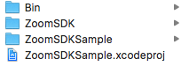

Sample.APP will be created in Bin/Realse folder.

